**Practical – 13**

**Name: - Hammad Khan**

**Roll no: - 20434**

Program 1: -

Program 2: -

Program 3: -

Program 4: -

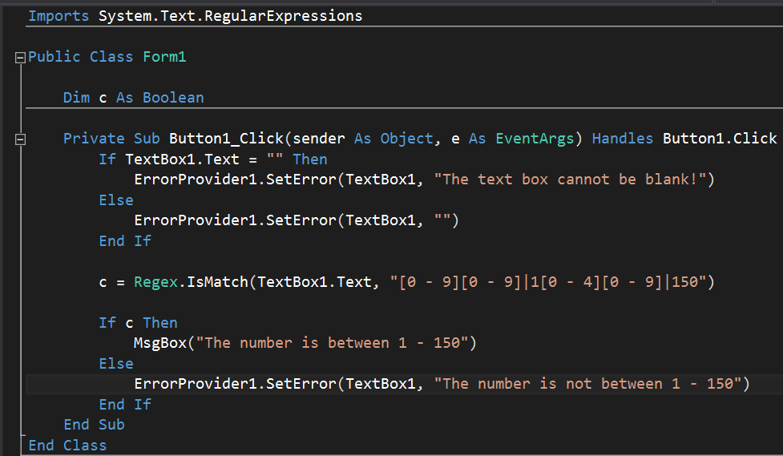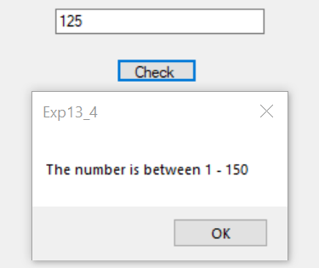

Program 5: -

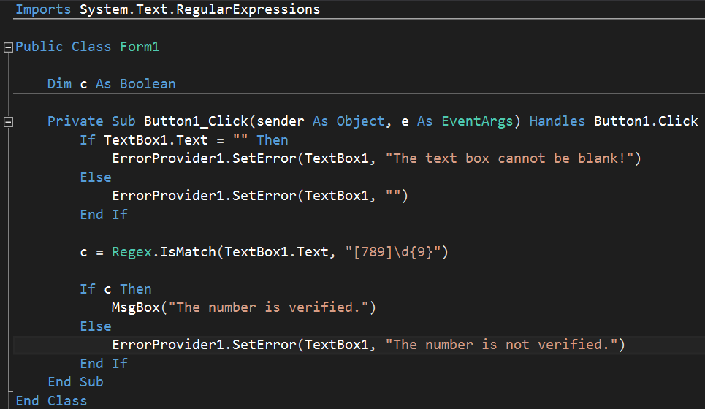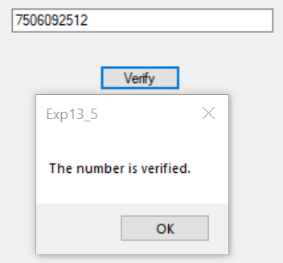

Program 6: -

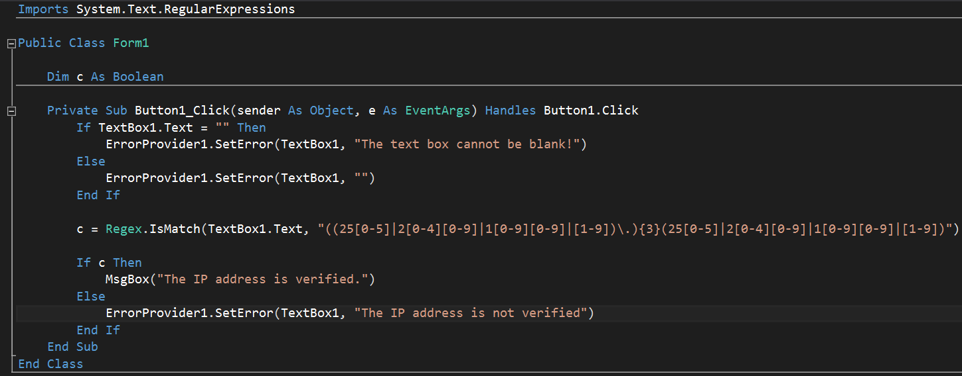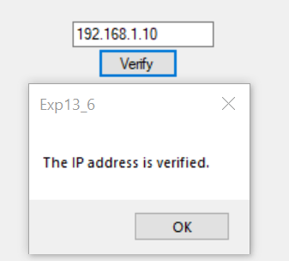

Program 7: -

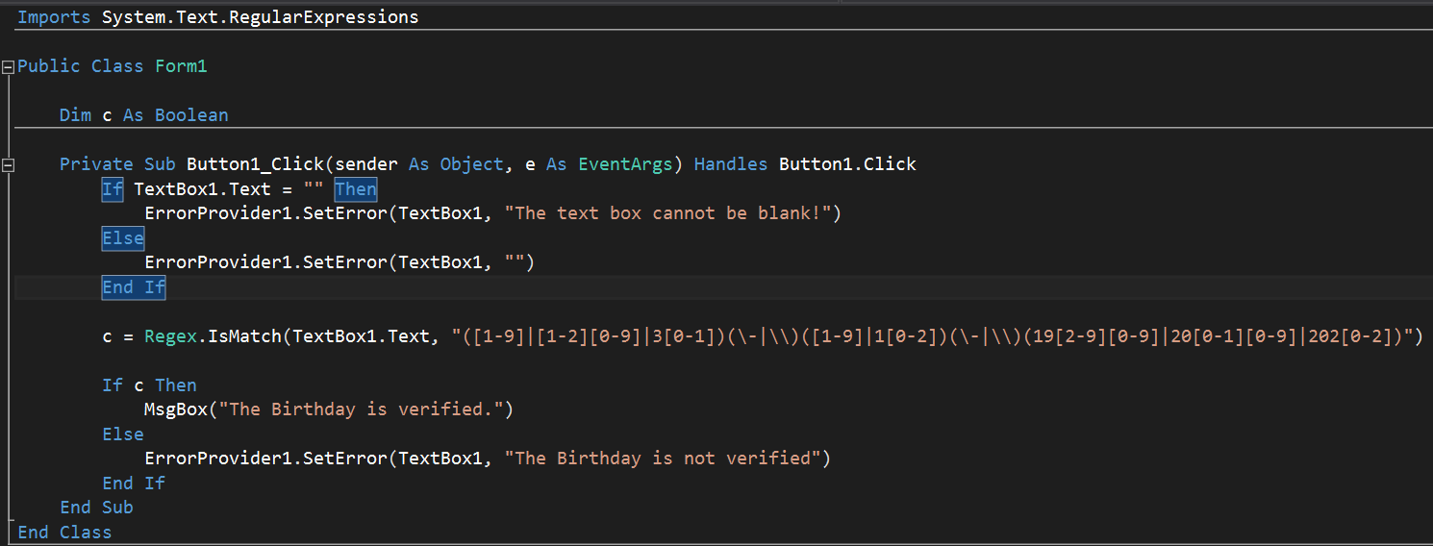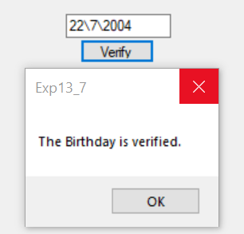

Program 8: -

